Name: Kaveri Avinash Jarhad
ID -260640160454
Q1)
create file employee.txt add below data
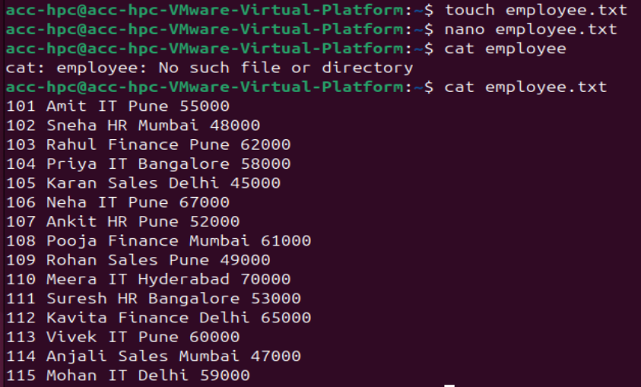

using grep
1. Display all employees who work in the IT department.
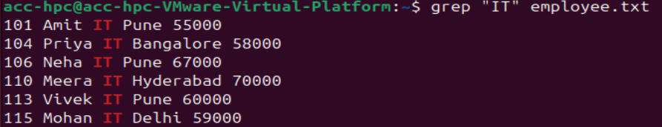

2. Display all employees located in Pune.
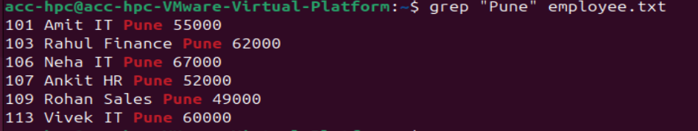

3. Display all employees whose name starts with the letter 'A'.

4. Find all employees whose salary contains the digit '7'.

5. Display line numbers along with all HR employees.
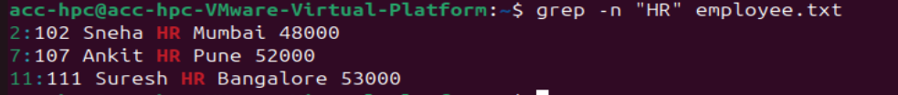

6. Count how many employees belong to the Finance department.

7. Display all employees except those from the Sales department.
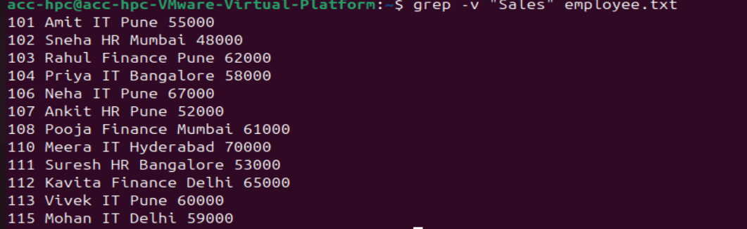

8. Display only the names of employees working in Mumbai.
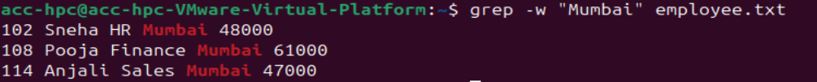

9. Display all employees whose salary is 60000 or above
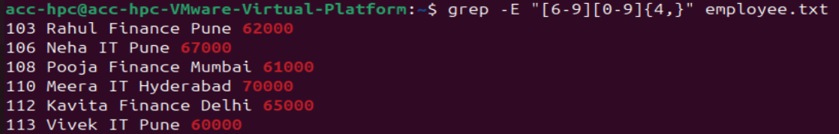

10. Search for the word IT without considering uppercase or lowercase letters.
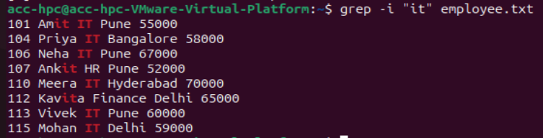

Q2) Display all files, including hidden files, in long listing format.
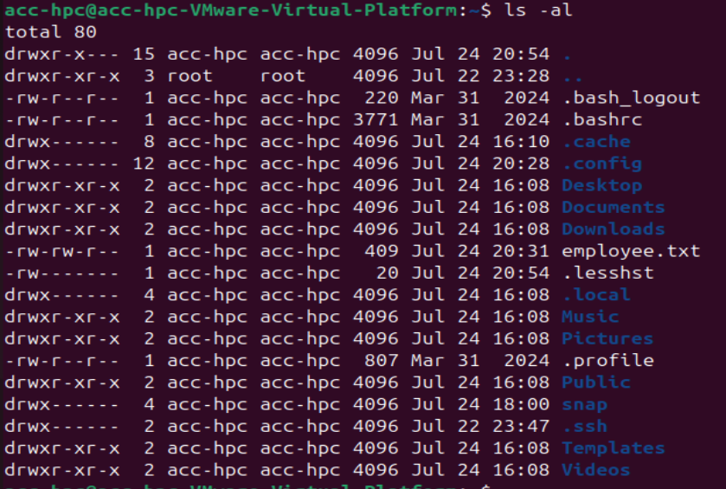

Q3) List all files sorted by modification time, with the newest file first.

Q4) Display only directories in the current directory.

Q5) List all files in reverse alphabetical order.

Q6) Display the size of each file in a human-readable format and sort them from largest to smallest.
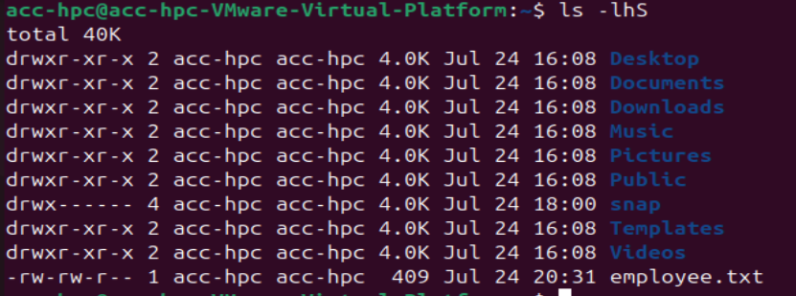

Q7) Stop One Process, Continue Another (use sleep for example)
Stop the process with PID.
Continue the process with PID (if it is stopped).
Verify the status of both processes.
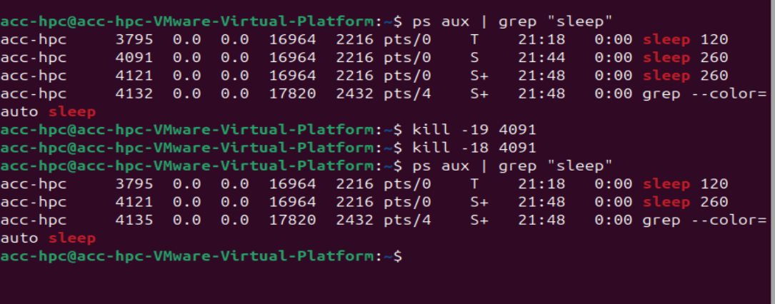

Q8) Kill Only One Process Among Multiple Similar Processes
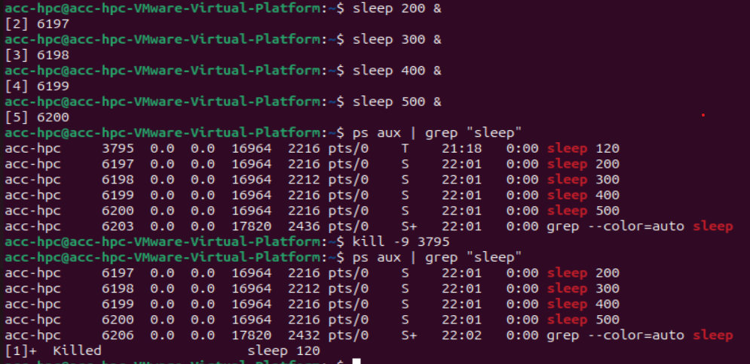

Q9) Stopped Process Doesn't Exit with Ctrl+C
Terminate the stopped process without first resuming it and verify.
